Southern Tier Chapter of
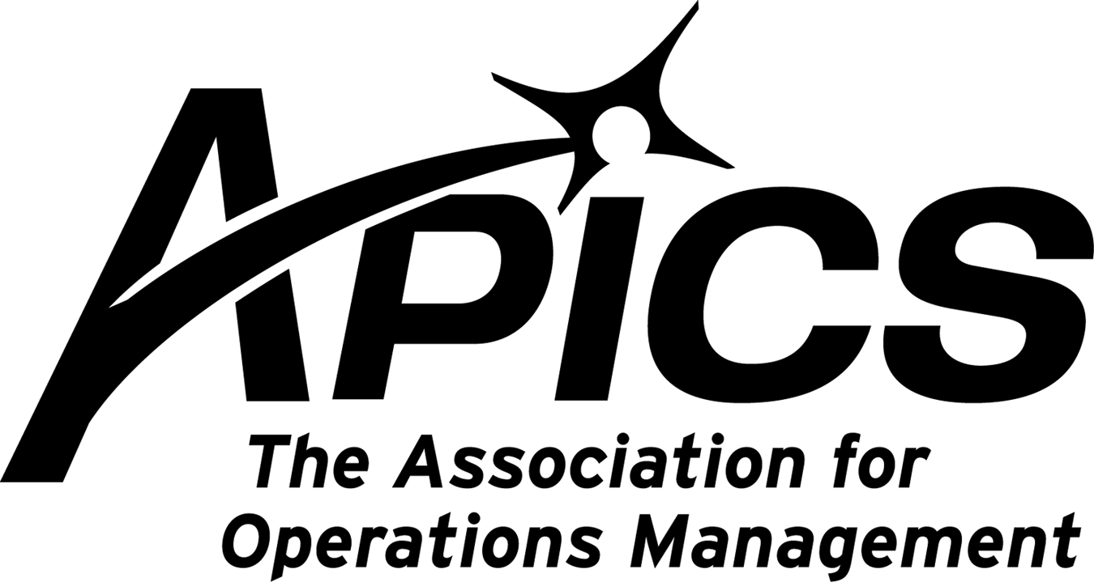

“Advancing productivity and innovation and competitive success.”

NO PDM DINNER THIS MONTH

Another of our students gains certification!
Marty Stantz from Endicott Interconnect has gained his CPIM certification! Marty has been attending Dave
Gardner’s CPIM review classes. The classes were paid for with education grants from New York State.
Congratulations to Marty!

Unemployed Membership Extension Program
If you are an unemployed APICS member whose membership is coming up for renewal and you are actively seeking work within the production and inventory management field, you may apply for an extension of membership benefits through the Unemployed Membership Extension Program. This program enables members seeking employment within the production and inventory management industry to
extend their membership for six months free of charge*. If you meet this criterion and are interested in applying for an extension of membership benefits due to unemployment, download an application or contact APICS Customer Support.

*Note: Members may apply for this extension up to three times for coverage over an 18 month period. Members apply for the extension through their local chapter, which must approve the request and waive chapter dues. Members approved for this waiver will receive electronic membership for the duration of the waiver, which entitles you to electronic communication of all member benefit materials.

Go to url http://www.apics.org/Membership/Join/unemployed.htm

Monday, February 15

Educational Opportunities!!!

1-day Seminar on
Supply Chain Management

Course Description

This 8-hour course is designed for all business people interested in learning more about the process of managing the supply chain. An APICS training certificate will be awarded for attendees. The course will cover the following areas:
- Understanding the forecasting process
- Building the forecast
- Measures that cross the boundaries to the supply chain
- Measuring suppliers
- Basics of supplier certification
- Data streams necessary to build a common process
- How ERP Business systems aid in supply chain management
- Roles of the players (suppliers, customers, management, purchasing, etc.)

Attendees will receive a basic foundation of learning in Supply Chain management and process improvement methodologies and tools. Actual examples and work exercises will help attendees better understand the processes discussed.

Course Deliverables
- Attendees will be introduced to Supply Chain methodologies and tools
- Attendees will leave with a Supplier Certification core process.
- Attendees will be presented with metrics that can be used to better drive improvement in their Supply Chain Management.
- Attendees will leave with an understanding of S&OP outputs required to shore up Supply Chain Management

Intended Audience
Materials Management
Master Schedulers
Supply Chain Managers
Buyers
Buyer/planners
Top Management

Place
EIT Huron Campus

Date and Time
Wednesday, 24 February 2010
8 AM until 5 PM

Cost for the course
$99 per attendee

Deadline for Registration is Wednesday, February 17, 2010
Contact Michael LoSapio at 607-786-3487 or Michael.losapio@synergyresources.net
Checks can be mailed to : Southern Tier APICS
c/o Michael LoSapio
2714 Plaza Drive
Endwell, NY 13760

About the Course Designer and Instructor
Donald H Sheldon is a frequent speaker, author and well-known instructor in continuous improvement methodologies. He is president of DHSheldon & Associates a premier business management consulting firm (www.sheldoninc.com). He has over 35 years of manufacturing management experience and has helped companies on several continents. Among other career experiences he has held the position of Vice President of Global Quality and Six Sigma at the NCR Corporation, a leader in ATM and point of sale equipment manufacturing. He has several books published, is APICS certified CFPIM, CIRM and CSCP, and is the APICS National Chair for OMBOK (Operations Management Body of Knowledge).

Educational Opportunities!!!

CPIM SERIES REVIEW CLASS
MASTER PLANNING OF RESOURCES

Broome Community College & Southern Tier APICS are offering the 2nd in the CPIM series review class starting Tuesday, February 16.

Master Planning of Resources

Explore the processes used to develop sales and operations plans and identify and assess internal and external demand and forecasting requirements. The course focuses on the importance of producing achievable master schedules that are consistent with business policies, objectives, and resource constraints. Topics include:

Demand Management
Sales and Operations Planning
Master Scheduling
Measuring Business Performance

10 Tuesday’s beginning February 16th at BCC (4-7pm).

Please contact Janet Hertzog at Hertzog_J@sunybroome.edu or call 607-778-5203 to register.

Your 2009-2010 Board of Directors

President Dave Gardner dgardner@akraturn.com
Education Director Don Sheldon dsheldon@stny.rr.com
Secretary Deb Unkel deb.unkel@raymondcorp.com
VP Membership Lee Schechter lschechter@stny.rr.com
VP Programs Michael LoSapio Michael.losapio@synergyresources.net
Executive VP /Director of Finance Steve Whited sjw6@meadwestvaco.com
Web site Michael LoSapio mlosapio@visualtechgroup.com
Publicity / Marketing Kelly Noreika Kelly.noreika@lmco.com

Southern Tier APICS
PO Box 1107
Binghamton NY 13902-1107

